3.8.2 Cascading Style Sheet Validation

For Index.css
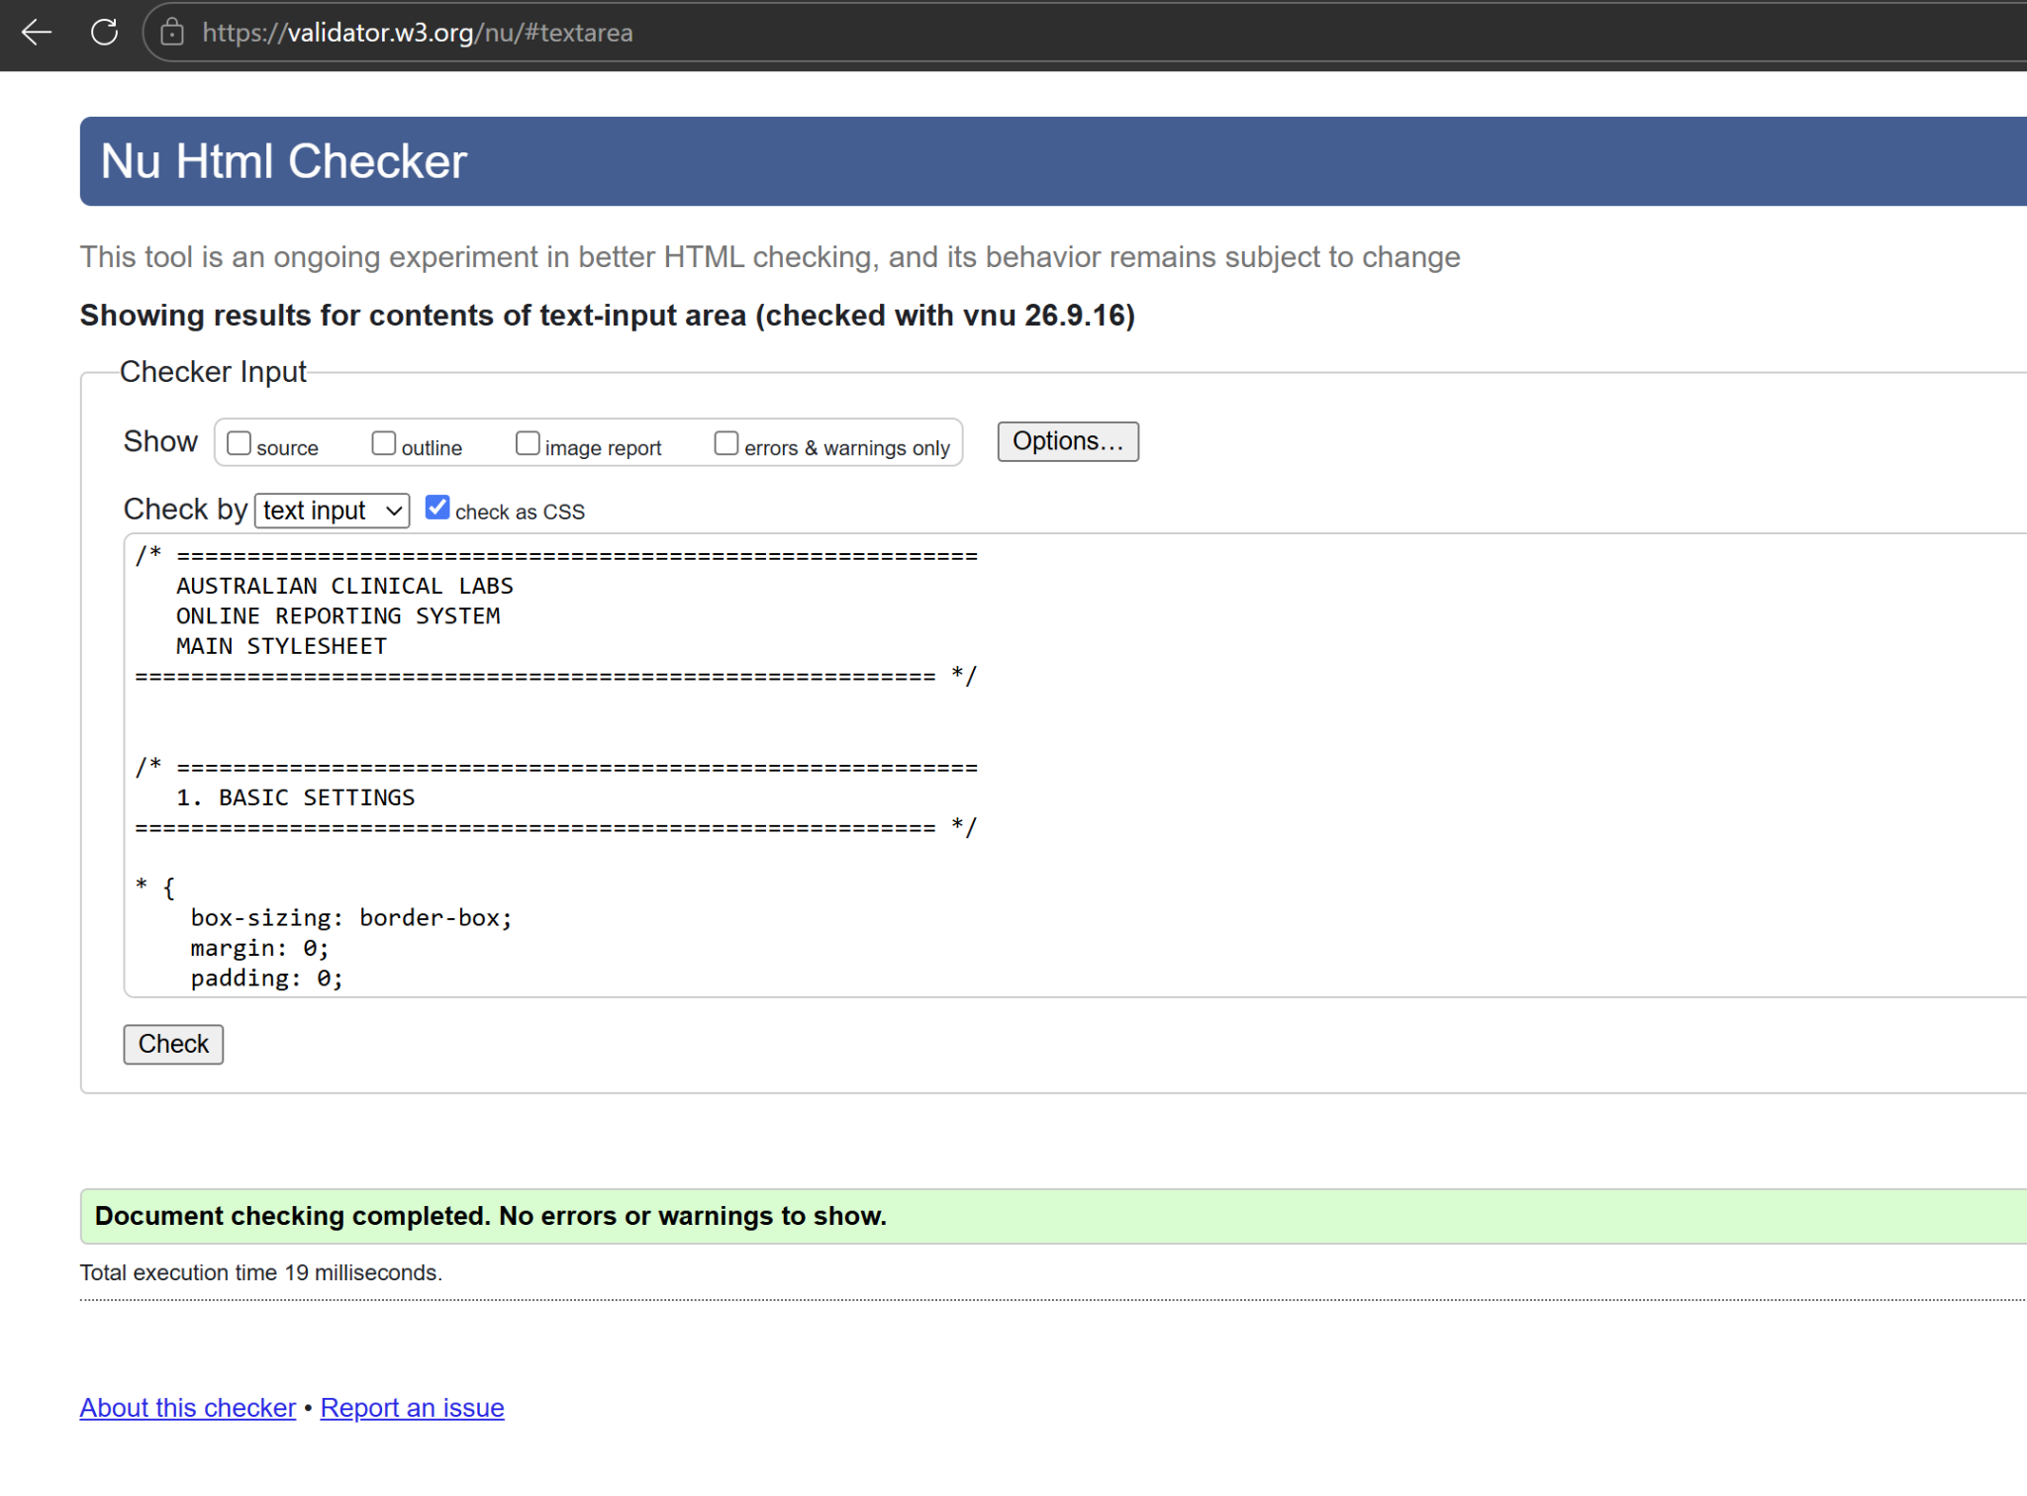

For style.css
